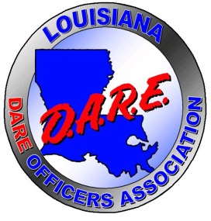
Louisiana D.A.R.E. Officers Association

Board of Directors

PRESIDENT
Altrice Taylor
Orleans Parish Sheriff’s Office
(504) 450-4629

VICE PRESIDENT
Ryan Smith
Calcasieu Parish Sheriff’s Office
(337) 515-0900

1st VICE PRESIDENT
Regina Rinaldi
St. Landry Parish Sheriff’s Office
(256) 527-2077

PAST PRESIDENT
Lisa Jackson
St. Bernard Parish Sheriff’s Office
(504) 314-1976

SECRETARY
Natasha Jones
Desoto Parish Sheriff Department (318) 349-5905

TREASURER
Chris Crawford
Richland Parish Sheriff’s Office
(318) 614-7372

SERGEANT AT ARMS
John Carr Jr.
Baton Rouge City Constables Office
(225) 931-7961

AT LARGE
Jacob Durrett
Vernon Parish Sheriff’s Office
(337) 718-6027

State-Wide Representative
Kirby Dawson
Shreveport City Marshal
(318) 458-7263

EDUCATIONAL ADVISOR
TBA

Notice of Quarterly Meeting

12/9/25

Please be advised the L.D.O.A. Quarterly Meeting will be held on Friday, January 16, 2026, in Lake Charles, LA. Below you will find the information on the meeting and two hotels that you can choose from:

L.D.O.A. Quarterly Meeting
Calcasieu Parish Sheriff’s Office Annex
4900 Highway 90 E
Lake Charles, La. 70615

Hotel Reservations
L’Auberge Casino-Resort
777 Avenue L’Auberge
Lake Charles, La. 70601
337-395-7777

Please be sure to bring your Tax-Exempt Form.
Tell them you are with DARE

Board Meeting @ 9:30 am (CLOSED)

Executive Committee Meeting @ 10:30 am

General Session @ 11:00 am (Open Membership)

Should you need any further information please feel free to contact me at any time. I look forward to seeing everyone there.

Altrice Taylor
L.D.O.A. President

